2 | METHODS

2.1. Host-parasite system

Black spot disease is a common fish infection in marine and freshwater ecosystems caused by Digenean trematodes (flukes) (Kurochkin & Biserova, 1996). While some aspects of the ecology of some of these parasite species (e.g., Posthodiplostomum cuticola, Uvulifer ambloplitis, Crassiphiala bulboglossa and Apophallus brevis) are relatively well studied, spatiotemporal infection patterns and their relation to environmental conditions remain poorly understood. Black spot-causing trematodes all have a similar complex life cycle requiring snails, fish and piscivorous birds as hosts (Figure 4). The parasite encysts under the skin, in the fins or the muscles of the fish host (Hoffman, 1956; Krull, 1932, 1934) where it can survive in a dormant form for a few years (Hoffman & Putz, 1965) until the infected fish gets eaten by a bird. The distinctive black cyst symptom results from melanin pigment stimulation in the fish tissues induced by trematode cercaria penetration (Davis, 1967; Lemly & Esch, 1984a). In the context of this study, we will refer to the black spot-causing trematodes as a guild because they have similar ecological requirements and cause the same symptoms in fishes.

Akin to other parasitic diseases, the infection parameters of the black spot disease can vary across time, space, and species. For example, the infection prevalence in bluegill sunfish (Lepomis macrochirus) inhabiting ponds is typically at its lowest around April/May and its maximum around September/October because cercariae are released through the summer and heavily infected fishes might be killed overwinter more often than less infected conspecifics (Lemly & Esch, 1984a, 1984b). Habitat characteristics that favor snail populations such as shallow waters, low water flow and abundant macrophytes have also been associated with higher abundance dans prevalence infection in fish-hosts (Marcogliese et al., 2001; Ondrackova et al., 2004). Hence, infection parameters of black spot disease in fish-hosts are usually higher in lentic systems and in the littoral zone rather than the pelagic zone (Ondrackova et al., 2004) because of a higher encounter probability. Since the black spot disease is caused by a parasite guild, a large range of fish species can be infected. However, some species tend to be more heavily infected than others. For instance, Lemly & Esch (1984) found that bluegill sunfish were more heavily infected than largemouth bass (Micropterus salmoides).

2.2. Study area

We sampled 15 lakes from six watersheds around Saint-Hippolyte, QC, Canada (45.92°N, 73.97°W) (Figure 5). The lakes Corriveau, Croche, Cromwell and Triton are in the protected area of the biology station of the Université de Montréal while the other lakes are surrounded by private properties. Considering their geographical proximity, we assumed that all the lakes are exposed to the same climatic conditions. The lakes were selected nonrandomly according to their accessibility and the availability of morphometric data (see Table S1 for the morphometric characteristics).

2.3. Data acquisition
Infection prevalence was estimated as the number of individuals infected with black spot disease divided by the total abundance of individuals of a given fish community. Three sampling methods (minnow traps, seine nets and transects) were used to assess prevalence infection and maximize the chances of catching different fish species. The field work took place from mid-June to end of August 2022 and was restricted to days without precipitation to limit sampling bias due to meteorological effects. Animal handling was approved by the Université de Montréal’s animal care committee (protocol number 22-025) and the scientific fishing permit was granted by the Ministère de l’Environnement, de la Lutte contre les changements climatiques, de la Faune et des Parcs (MELCCFP) of Québec (2022-05-16-1971-15-S-P).
Sampling effort within lakes was determined according to the lake surface area, except for minnow traps (see Table S2) as setting these traps requires less time and manipulation than the other methods. Seine sampling varied between four and eight efforts while the number of transect sites varied between two and six per lake. 15 minnow traps were set in each lake to maximize the number of captures.
The minnow trap and seine net samplings were both conducted on the same day for each lake. The seine samplings occurred during daytime in habitats lacking large obstacles like trunks and rocks in which the net can get stuck. Two sizes of minnow traps were set at approximately equal distance along the shore at 4PM and pulled four hours later, to target species that are most active at dusk. All traps sat on the bottom substrate, but there were no other habitat restrictions for the minnow trap placement. Half of the traps (3 large and 5 small traps) were baited with bread to sample various feeding preferences and behavioral habits. The fishing gear dimensions are available in Table S3. All the fishing gear was pressure washed and sun dried between lakes following MELCCFP recommendations to prevent exotic species contamination.
All captured fishes were counted, identified to the species level, and measured (estimation of the total length to the nearest centimeter) directly after capture and subsequently released. Northern redbelly dace (Chrosomus eos) and finescale dace (Chrosomus neogaeus) individuals were identified as Chrosomus spp. as the two species hybridize in these lakes and cannot be distinguished based on morphology in the field (Leung et al., 2017). The presence of black cysts was assessed by examining the left side of the fish (De Bonville, in prep.). Juveniles and adults were included in this study as both life stages are vulnerable to black spot disease.
Fifty-meter snorkeling transects along the shore were conducted to assess black spot infection prevalence in the fish communities. Due to time constraints, lakes Beaver, Montaubois, Tracy and St-Onge were excluded from the transect sampling because of low fish abundance in the fishing samples or poor water transparency. We selected sites that were approximately between 0.5 and 3.0 m deep, not fully covered by macrophytes, not obstructed by docks and preferably with some vegetation, rock, or trunk refuges for the fishes. The sites were selected and flagged every ten meters at the end-May 2022. The transects were performed simultaneously by two observers each monitoring one-meter field of view in front of them and moving forward at a pace of three minutes per ten meters. The fishes coming in the field of view from behind the observer were not counted. All the fishes were identified to the lowest taxonomic level possible and visible black spot infection was noted. All cyprinids were grouped into the same category since they move fast and are more difficult to identify at the species level in these circumstances.

Following the prevalence transect assessment, we completed the habitat description. The percentage of four substrate categories (silt, sand, rock, and boulder), the macrophyte coverage, the number of trunks (or large branches), and the mean depth was estimated for each 10-meter transect section. The mean estimate of each category was then calculated for all variables at the transect-scale. Temperature, dissolved oxygen, conductivity and pH were measured at mid-depth (around 0.3 to 2 meters) at the beginning of every transect with a YSI ProDSS Multi-Parameter Water Quality Meter. 1 L of unfiltered water was taken at mid-depth in previously acid-washed HDPE bottle for carbon and nutrient content analyses. The samples were placed in a dark cooler and transported back to the field station laboratory where the 1 L samples were separated in previously acid-washed 40 mL vials to measure total organic carbon (TOC), and 500 mL HDPE bottle for total nitrogen (TN) and total phosphorus (TP). TOC samples were placed in a 4°C refrigerator and analyzed within the week while TN and TP samples were kept in a -20°C freezer until later processing. TOC sample contents were measured on a Siervers M5310 C Laboratory Total Organic Carbon Analyzer. TN and TP samples were oxidized with persulfate and autoclaved the day before analysis following EPA methods 353.2 and 365.3 respectively (US EPA, 1978, 1993). TN concentrations were measured on a Lachat QuikChem 8500 analyzer and TP concentrations were analyzed on a Asoria-Pacific Astoria2.

2.4. Statistical analyses

We employed the following procedures to describe the black spot prevalence pattern across multiple scales (landscape, lake and site). All data manipulations and analyses were conducted using R (version 4.2.3). Lake Tracy was excluded from the lake-scale analysis because of low fish abundance data obtained with the fishing methods (N = 1 individual sampled).

For the landscape-scale analysis, we looked at the effect of the sampling design (here sampling method and sampling effort) on the estimation of landscape prevalence. We used a resampling approach on the data from the different sampling methods (minnow trap, seine net, transect, and all methods combined) to investigate how the infection prevalence estimate changes with an increasing sampling effort gradient. The sampling effort prevalence was calculated as the number of infected individuals divided by the total number of individuals regardless of the lake sampled. For each sampling method, we randomly selected N number of samples from our data to estimate the landscape (weighted mean) prevalence. The operation was repeated 999 times for a sampling gradient from 1 to 35 samples. A local regression was then fitted to the landscape estimates generated by our simulation of each sampling effort value (N) for visualization of the tendency through the sampling gradient. We estimated the final landscape prevalence and the approximate sampling effort needed to reach a steady prevalence value for each method.

For the lake-scale analysis, we examined the frequency distribution of the lakes’ prevalence according to the sampling method. The mean infection prevalence was previously calculated for each lake, and visualization was made with histograms set at six bins to avoid gaps. The distributions were then compared with the map of the study area for spatial patterns.

For the site-scale analysis, we modeled the relationships between environmental drivers and the community infection prevalence on a transect level. We used the prevalence data from the transect method because it is the only method that allows an accurate association of infection prevalence with all environmental variables (including those measured at the site-scale), thus can best reveal the key drivers of infection prevalence. Prior to analysis, we explored the data for outliers in both the response and explanatory variables, for collinearity between explanatory variables, and for non-linearity in the relationships between the response and the explanatory variables following recommendations by Zuur et al. (2009). We decided to keep the outliers in the analysis because we have limited samples, and because it reflects the environmental heterogeneity. Our data showed some non-linear patterns. Consequently, we used generalized additive models in a mixed-model framework (GAMMs) fitted using marginal likelihood (ML) estimation to account for spatial clustering of sites from the same lakes. We used a quasi-binomial family distribution because our response variable (infection prevalence) is a proportion constrained between 0 and 1 and, to account for overdispersion in the data. The optimal amount of smoothing (λ) was internally determined by the modeling function from the mgcv package (Wood, 2017). Since we had a small sample size for the transect method (N = 39), we modeled one environmental variable at the time with a cubic spline and a random effect on the lake variable to save degrees of freedom. The deviance explained (D²) was used as a measure of the model fit. The model validations were conducted with gratia package (Simpson, 2023). The visualization of the partial effects was made with gratia (Simpson, 2023) and ggplot2 (Wickham, 2016) packages.
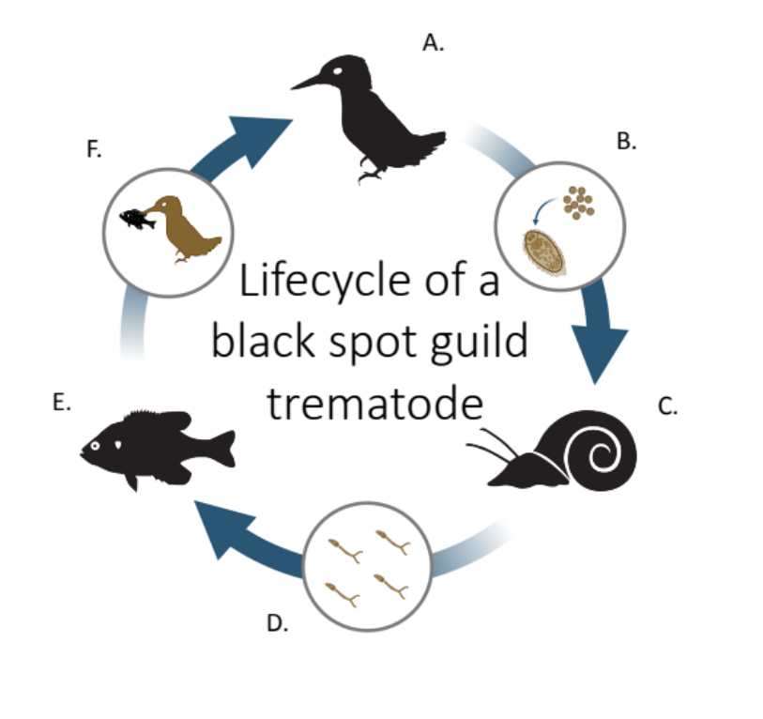
FIGURE 4

The typical lifecycle of a parasite species causing the black spot disease in freshwater fishes. (A) The definitive host is a piscivorous bird, usually a kingfisher or a great blue heron. The metacercariae mature to its adult form and reproduce in the bird digestive system. (B) The eggs are released in the water through the bird feces and grow into miracidia (first larval form). (C) The miracidia infect the first intermediate host, a freshwater snail of Helisoma or Planorbella genus. The larvae develop into free-living stage cercariae (second larval form) and leave the snail. (D) The cercariae swim until they encounter a potential fish host. (E) The second intermediate host is a fish. The cercariae penetrate under the skin or the fins and transform in the metacercaria form. (F) The fish is eaten by a definitive host.

Angers, B., & Schlosser, I. J. (2007). The origin of Phoxinus eos-neogaeus unisexual hybrids. Molecular Ecology, 16(21), 4562‑4571. https://doi.org/10.1111/j.1365-294X.2007.03511.x
Davis, H. S. (1967). Culture and Diseases of Game Fishes. University of California Press.
Hoffman, G. L. (1956). The Life Cycle of Crassiphiala bulboglossa (Trematoda : Strigeida). Development of the Metacercaria and Cyst, and Effect on the Fish Hosts. The Journal of Parasitology, 42(4), 435‑444. https://doi.org/10.2307/3274528
Hoffman, G. L., & Putz, R. E. (1965). The Black-Spot (Uvulifer ambloplitis : Trematoda: Strigeoidea) of Centrarchid Fishes. Transactions of the American Fisheries Society, 94(2), 143‑151. https://doi.org/10.1577/1548-8659(1965)94[143:TBUASO]2.0.CO;2
Krull. (1932). Studies on the development of Cercaria bessiae Cort and Brooks, 1928. Journal of Parasitology, The, 19(165), 1934. /z-wcorg/.
Krull, W. H. (1934). Cercaria bessiae Cort and Brooks, 1928, an Injurious Parasite of Fish. Copeia, 1934(2), 69‑73. https://doi.org/10.2307/1435795
Kurochkin, I. V., & Biserova, L. I. (1996). [The etiology and diagnosis of « black spot disease » of fish]. Parazitologiia, 30(2), 117‑125.
Lemly, A. D., & Esch, G. W. (1984a). Population Biology of the Trematode Uvulifer ambloplitis (Hughes, 1927) in Juvenile Bluegill Sunfish, Lepomis macrochirus, and Largemouth Bass, Micropterus salmoides. The Journal of Parasitology, 70(4), 466‑474. https://doi.org/10.2307/3281394
Lemly, A. D., & Esch, G. W. (1984b). Population Biology of the Trematode Uvulifer ambloplitis (Hughes, 1927) in the Snail Intermediate Host, Helisoma trivolvis. The Journal of Parasitology, 70(4), 461. https://doi.org/10.2307/3281393
Leung, C., Duclos, K. K., Grünbaum, T., Cloutier, R., & Angers, B. (2017). Asymmetry in dentition and shape of pharyngeal arches in the clonal fish Chrosomus eos-neogaeus : Phenotypic plasticity and developmental instability. PLOS ONE, 12(4), e0174235. https://doi.org/10.1371/journal.pone.0174235
Marcogliese, D. J., Dumont, P., Gendron, A. D., Mailhot, Y., Bergeron, E., & McLaughlin, J. D. (2001). Spatial and temporal variation in abundance of Diplostomum spp. In walleye (Stizostedion vitreum) and white suckers (Catostomus commersoni) from the St. Lawrence River. Canadian Journal of Zoology, 79(3), 355‑369. https://doi.org/10.1139/z00-209
Ondrackova, M., Bartosova, S., Valova, Z., Jurajda, P., & Gelnar, M. (2004). Occurrence of black-spot disease caused by metacercariae of Posthodiplostomum cuticola among juvenile fishes in water bodies in the Morava River Basin. Acta Parasitologica, 3(49). https://www.infona.pl//resource/bwmeta1.element.agro-article-5d8e90ef-9221-415e-b62f-e6e574152bf0
Simpson, G. (2023). gratia : Graceful ggplot-Based Graphics and Other Functions for GAMs Fitted using mgcv. (R package version 0.8.1.42) [Logiciel]. https://gavinsimpson.github.io/gratia/
US EPA. (1978). Method 365.3 : Phosphorous, All Forms (Colorimetric, Ascorbic Acid, Two Reagent).
US EPA. (1993). Method 353.2, Revision 2.0 : Determination of Nitrate-Nitrite Nitrogen by Automated Colorimetry.
Wickham, H. (2016). ggplot2 : Elegant Graphics for Data Analysis. [Logiciel]. Springer-Verlag New York.
Wood, S. N. (2017). Generalized Additive Models : An Introduction with R, Second Edition (2e éd.). Chapman and Hall/CRC. https://doi.org/10.1201/9781315370279
Zuur, A. F., Ieno, E. N., Walker, N., Saveliev, A. A., & Smith, G. M. (2009). Mixed effects models and extensions in ecology with R. Springer. https://doi.org/10.1007/978-0-387-87458-6

